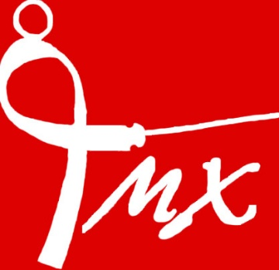
MX Fencing Club
Sabre Fencing Club in Kent
mxfencing@gmail.com

Risk assessment Form
To be filled out by a Committee member at the beginning of every term and to be kept on file.

 | VENUE – SEVENOAKS PREPARATORY SCHOOL
Name of person doing the check:
Date of check:
Training area: | MAIN SPORTS HALL (highlight answers in RED)
Is the entrance/exit safe? | Yes | No | Action required: | Date action completed:
Are the fire doors working? | Yes | No | Action required: | Date action completed:
Is the flooring in good order? | Yes | No | Action required: | Date action completed:
Are the electric sockets in good order? | Yes | No | Action required: | Date action completed:
Are evacuation procedures clearly signposted? | Yes | No | Action required: | Date action completed:
 | EQUIPMENT
Check that ALL equipment is in good working order and report any faults
Are the following, all safe?
Chest Protectors | Yes | No | Action required: | Date action completed:
Plastrons | Yes | No | Action required: | Date action completed:
Breeches | Yes | No | Action required: | Date action completed:
Jackets | Yes | No | Action required: | Date action completed:
Lames | Yes | No | Action required: | Date action completed:
Masks | Yes | No | Action required: | Date action completed:
Wires | Yes | No | Action required: | Date action completed:
Swords | Yes | No | Action required: | Date action completed:
Electric boxes | Yes | No | Action required: | Date action completed:
Scoring boxes | Yes | No | Action required: | Date action completed:
Spools | Yes | No | Action required: | Date action completed:
 | FENCERS
Is the attendance register up to date? | Yes | No | Action required: | Date action completed:
Is medical information up to date? | Yes | No | Action required: | Date action completed:
Are emergency contact details for under 18’s up to date? | Yes | No | Action required: | Date action completed:
Risk assessment completed: | Signed:

Written: August 2023
Reviewed:

